

LAB REPORT 03

SUBMITTED TO : MR. MUBASHIR IQBAL
SUBMITTED BY: AHMED SALEEM RANA
REG ID: 24-CYS-023
SECTION : B
COURSE TITLE: ARTIFACIAL INTEELLIGENCE LAB

HITEC UNIVERSITY, TAXILA CANTT

TASK 01

Write a Python function to calculate the factorial of a number (a non- negative integer). The function accepts the number as an argument.
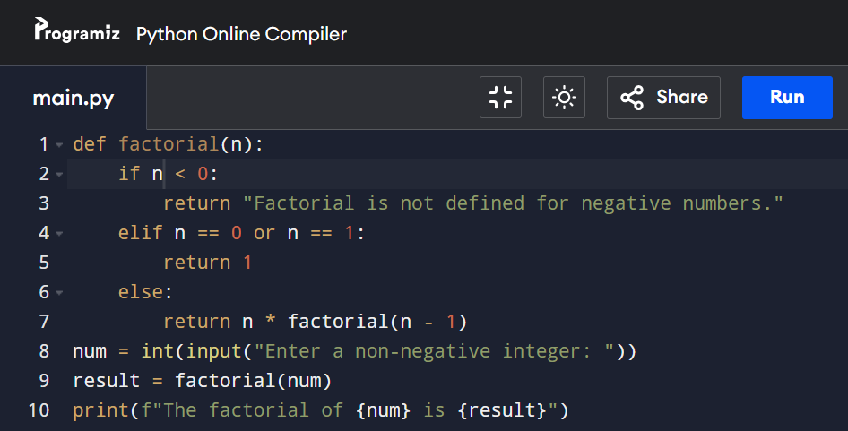
INPUT:

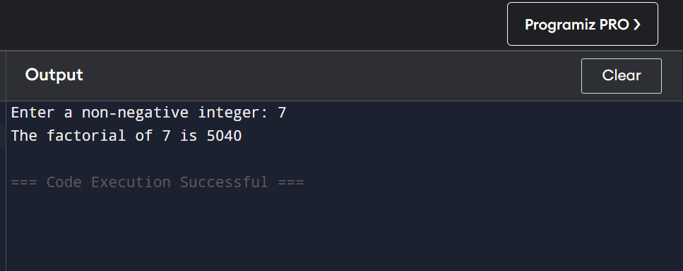
OUTPUT:

EXPLANATION:
This program defines a function factorial(n) that calculates the factorial of a number using a loop. It multiplies all numbers from 1 to n and stores the result in fact. The user enters a number, and the program prints its factorial using the function.

TASK 02

Write a Python function that takes a list and returns a new list with unique elements of the first list. a) Sample List : [1,2,3,3,4,4,5,3,7,5] b) Unique List: [1, 2, 3, 4, 5, 7]
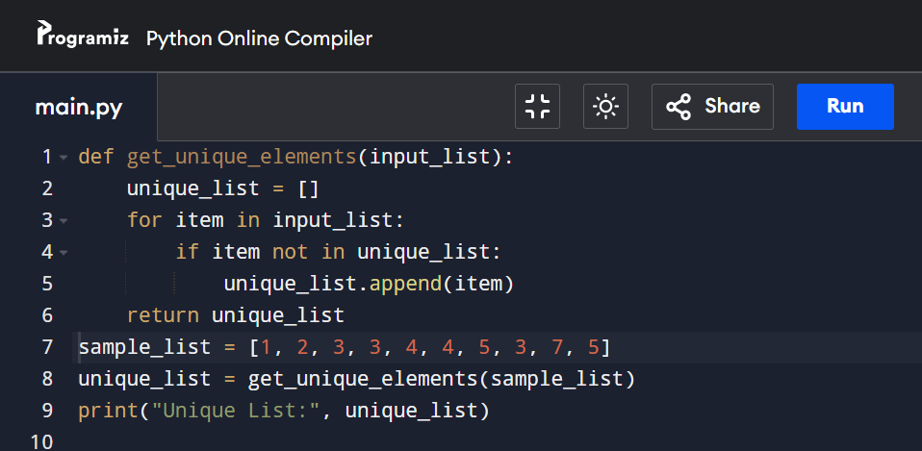
INPUT:

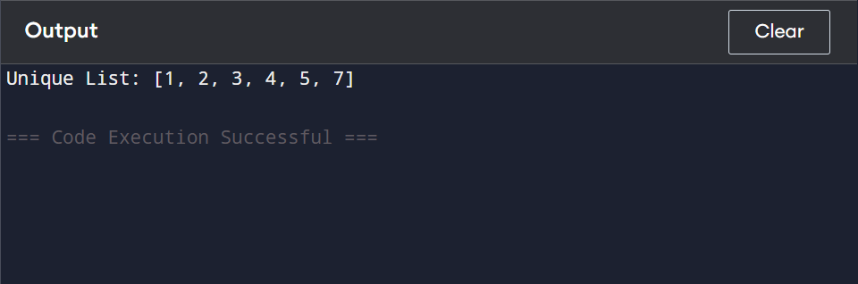
OUTPUT:

EXPLANATION:
This program defines a function unique list(lst) that removes duplicate elements from a list. It converts the list into a set (which automatically removes duplicates) and then back into a list. The program then prints the unique elements from sample list.

TASK 03

Write a Python function to show the first ‘n’ even numbers and then return the sum and product of that even numbers outside the function.
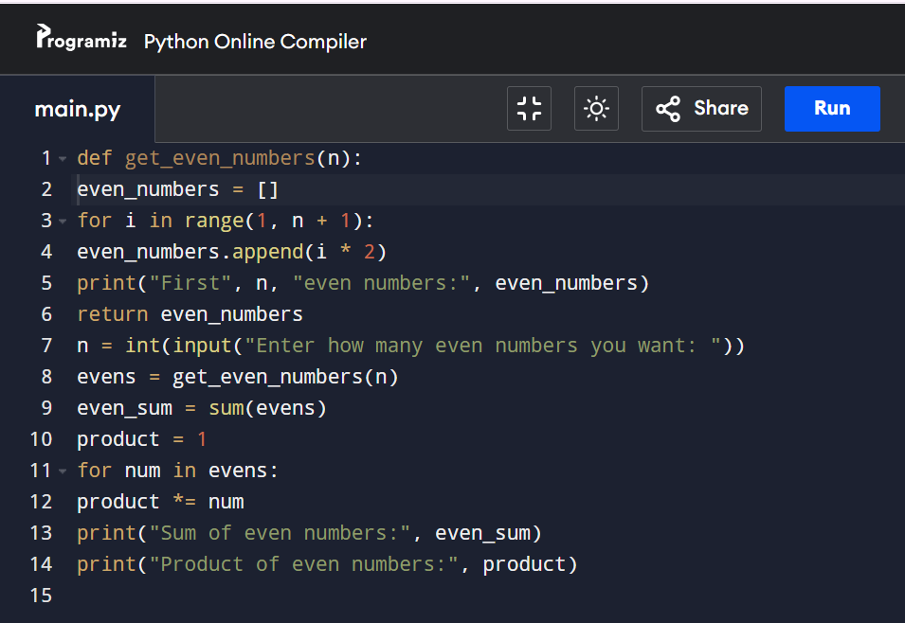
INPUT:
.
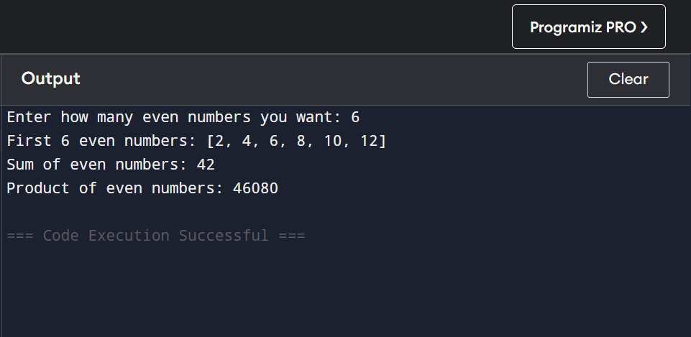
OUTPUT:

EXPLANATION:
This program defines a function even_numbers(n) that prints and returns the first n even numbers. It creates even numbers by multiplying each number from 1 to n by 2. The main program takes a number from the user, calls the function, and stores the even numbers in nums. Then it calculates and prints the sum of all even numbers using sum(nums) and the product using a loop

TASK 04

Write a python program to match two string using functions.
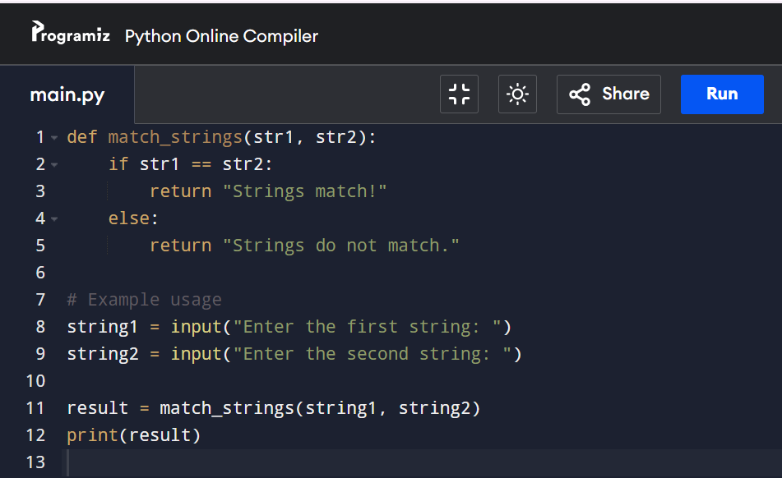
INPUT:
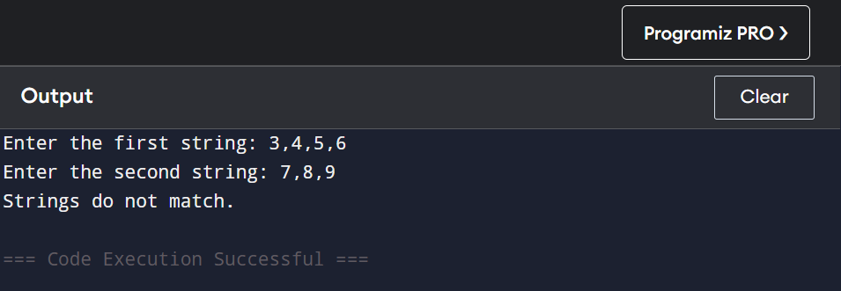
OUTPUT:
EXPLANATION:
This program defines a function match_strings(str1, str2) that compares two strings. If both strings are the same, it prints "Strings match!", otherwise it prints "Strings do not match." The user is asked to enter two strings, and the function checks whether they are equal or not.

TASK 05

Write a python program to name user login system using function.
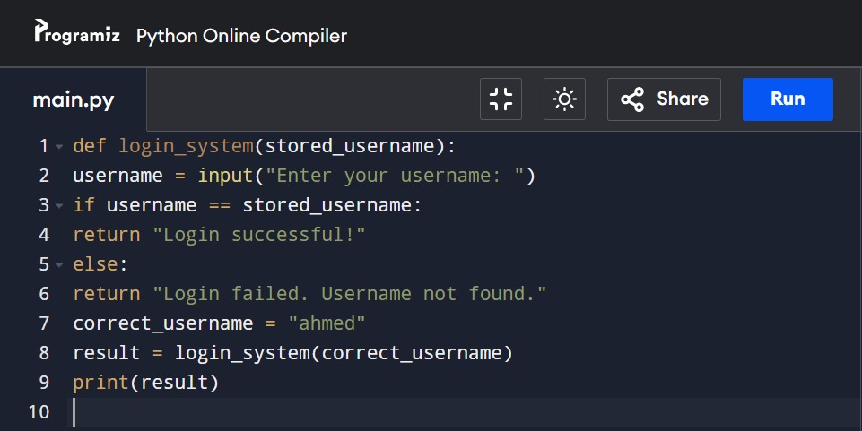
INPUT:
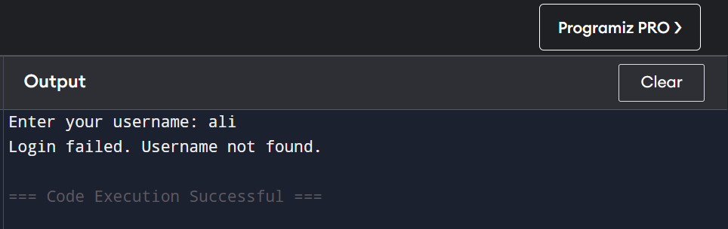
OUTPUT:

EXPLANATION:
This program defines a function login(username, password) that checks if the entered username and password are correct. If the username is "admin" and the password is "1234", it prints "Login Successful!" Otherwise, it prints "Invalid Username or Password!" The user enters their login details, and the function verifies them.
CONCLUSION:
These Python programs show the basic use of functions, loops, and conditions. The factorial program finds the product of numbers from 1 to n. The unique list program removes duplicate values from a list. The even numbers program displays the first n even numbers and finds their sum and product. The string matching program checks if two strings are the same, and the login program verifies user name and password.
GITHUB REPOSITORY LINK:

